POS INVENTORY MANAGEMENT

MEMBERS:

Adolfo, Moises G.

Aurelio, Glenmhar P.

Junsay, John Kevin

Pongaron, Cristine Joy S.

Valencia, Celine N.

* DESCRIPTION OF THE SYSTEM

The System is a B2B2C marketplace model in which so-called merchants sell goods with different suppliers. The company offers products in some of the following categories:

Electronic Devices

Electronic Accessories

TV & Home Appliances

Health & Beauty

Babies & Toys

Groceries & Pets

Home & Living

Women's Fashion

Men's Fashion

Fashion Accessories

Sports & Lifestyle

Automotive & Motorcycles

In order to provide a better quality transaction for their customers, the System makes sure to handle the accompanying processes such as shipping, payment, or reclamations.

* SELF EVALUATION

Adolfo, Moises G. 20

Aurelio, Glenmhar P. 20

Junsay, John Kevin 20

Pongaron, Cristine Joy S. 20

Valencia, Celine N. 20

100

The first frame of this website is for the log in returning Users username and password and sign-up for the new customer returning first name, last name, email add, password, and membership, etc.

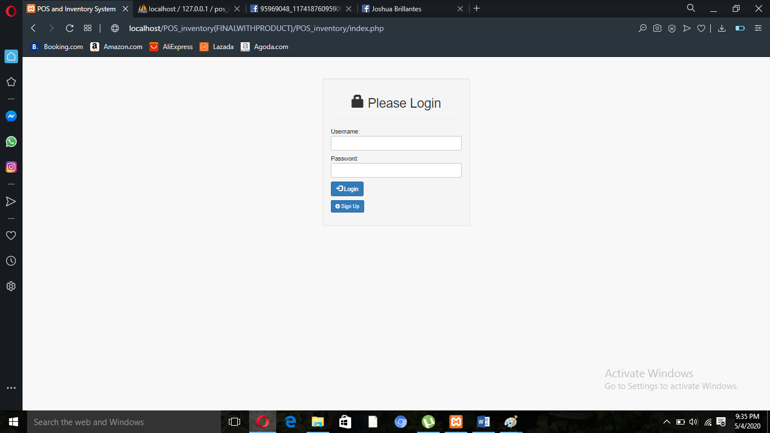

In this admin page. We can see the details of every other admins, customers, employees, suppliers, warehouse and delivery. Admins can add new admin, employee, suppliers, warehouse, delivery and customers. Admins can see the products of the suppliers and admins can also add the product. Admins can also see the details of Logins and logouts of other users. It also have sale report and inventory report. In sale report is the product who already processed, in inventory report we can see the stocks of every products.

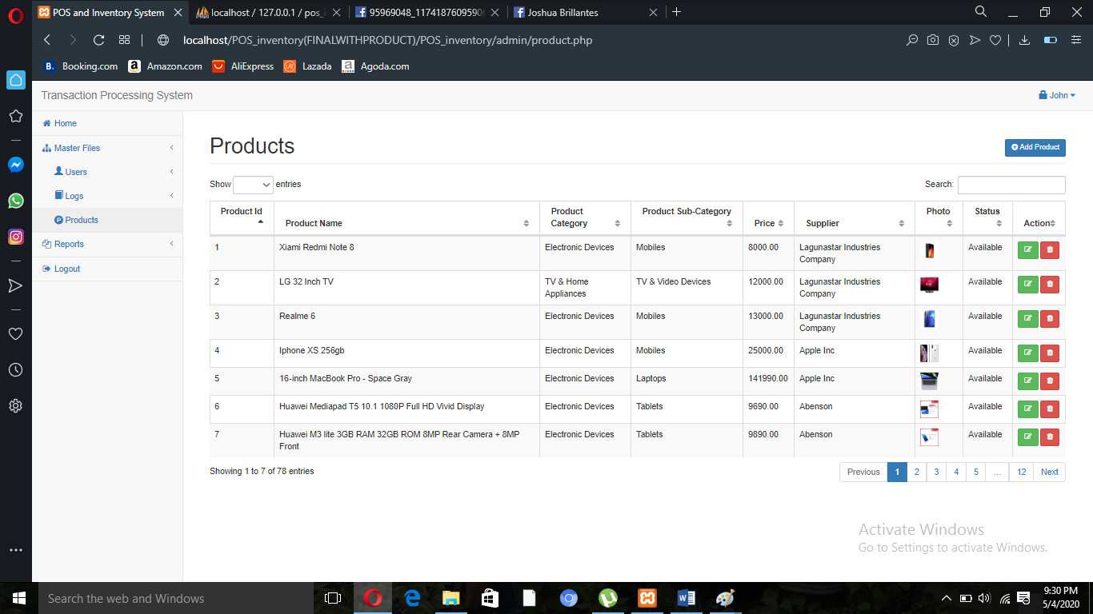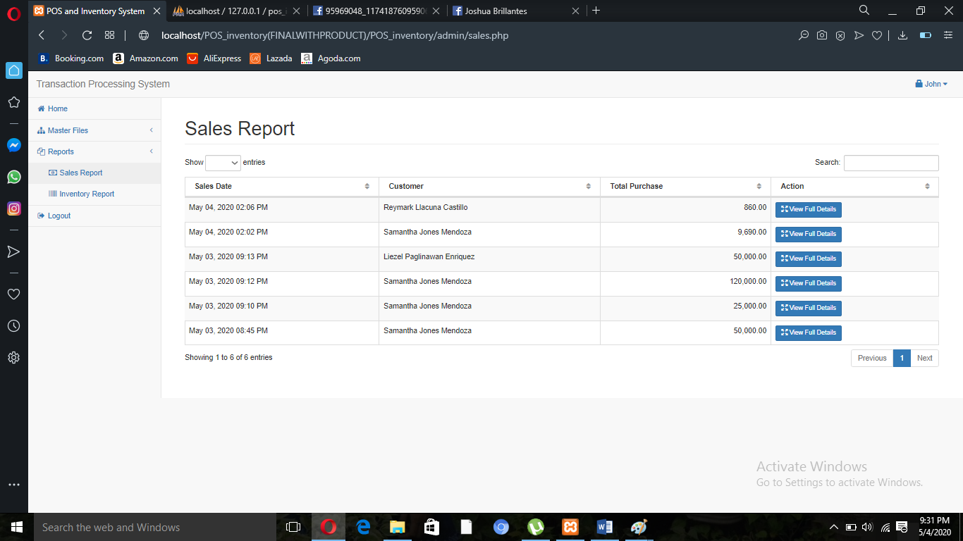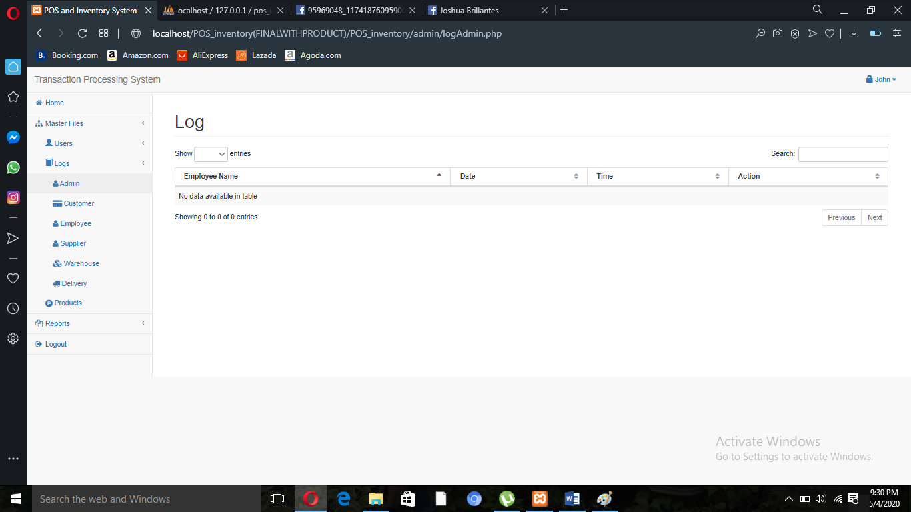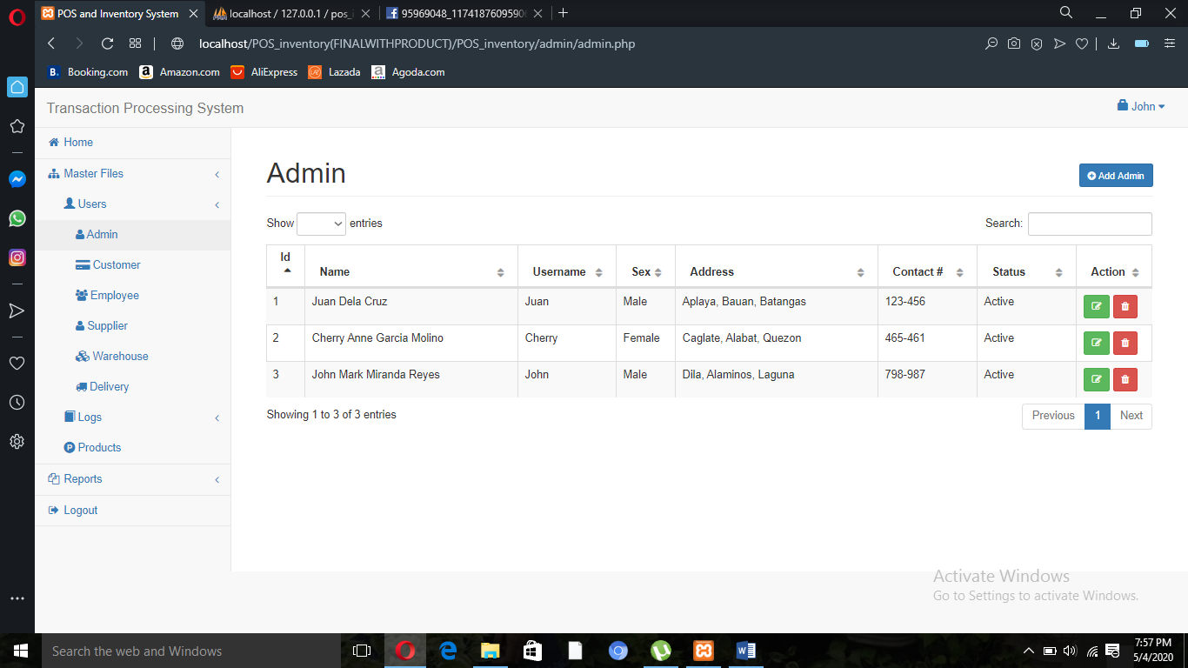

This page is for the customer where they can pick or select the products that they want to buy, they only need to click the Add to Cart button, then go to my cart the customer will see the product/s that they order. If the customer check out, they will receive the receipt. When the customer confirm the order, the site will go to order history and they can see if their order is already shipped or decline order. After the customer receive the order, the history will update and the record of the order will see.

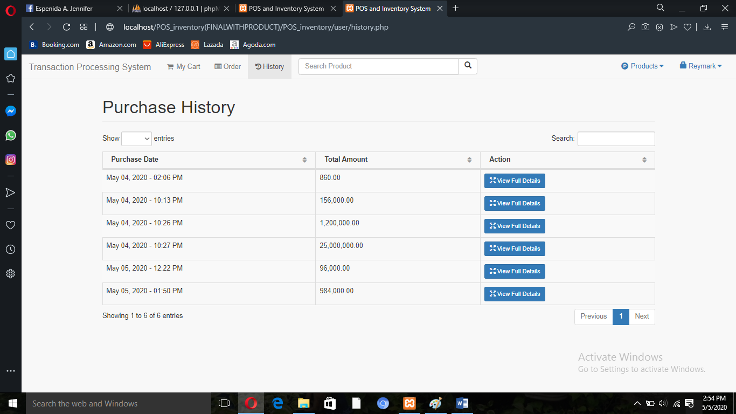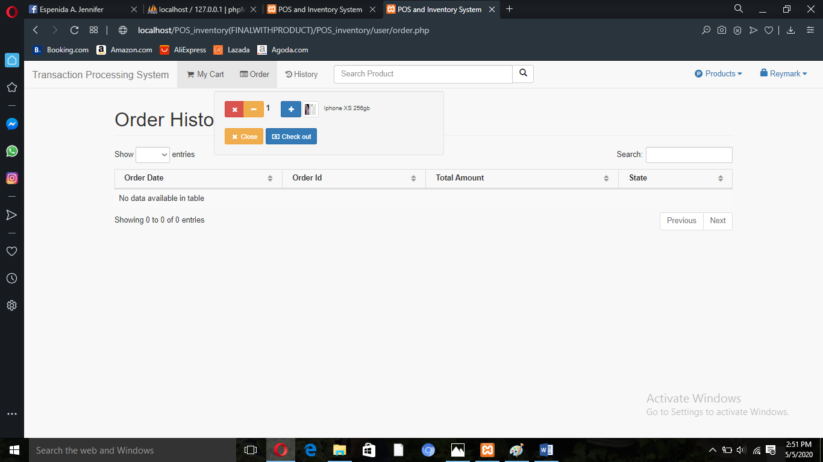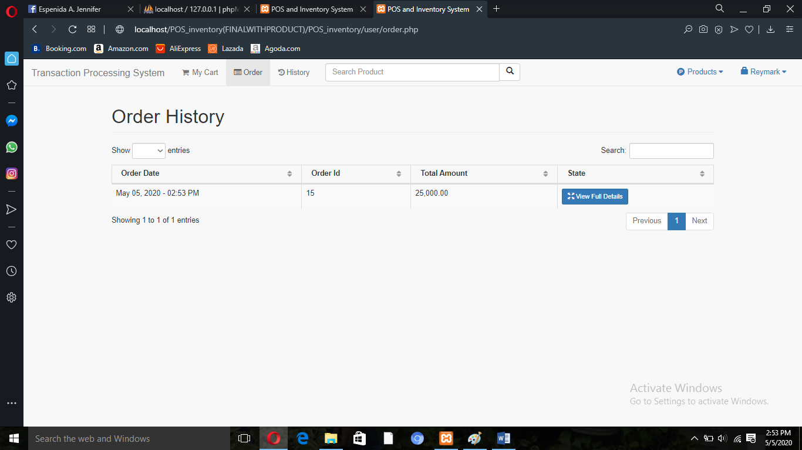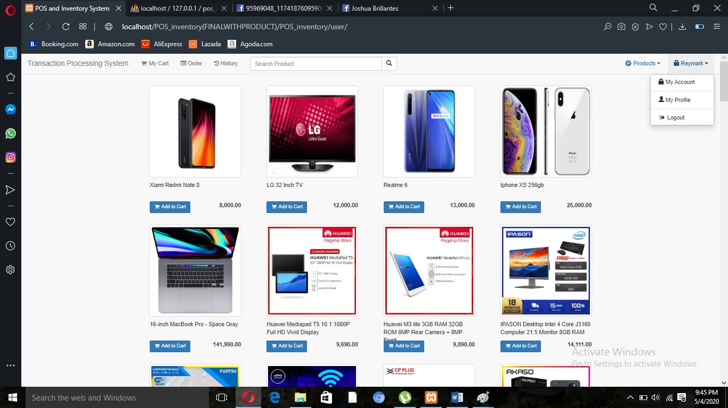

In supplier page. We can see the products where the supplier sell. The supplier can add a new Item or add a stock to an existing product. The supplier can edit, delete an item. When the customers ordered, the suppliers can see the selected item with the customer id. The supplier can see How many items and what item that the customers ordered. The supplier can approve and even decline the customer’s order. It also have sales report. And lastly, the supplier will see the total amount he/she gain.

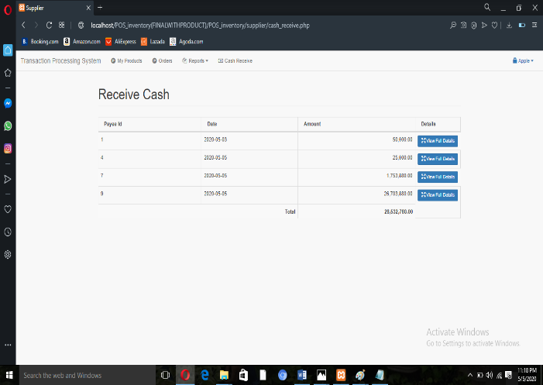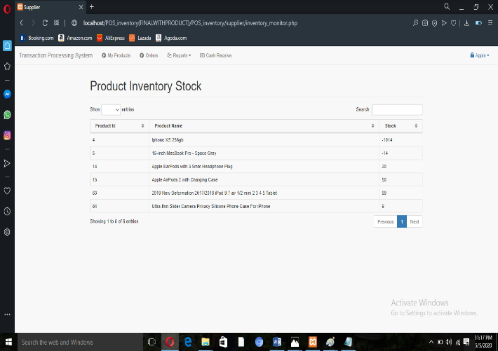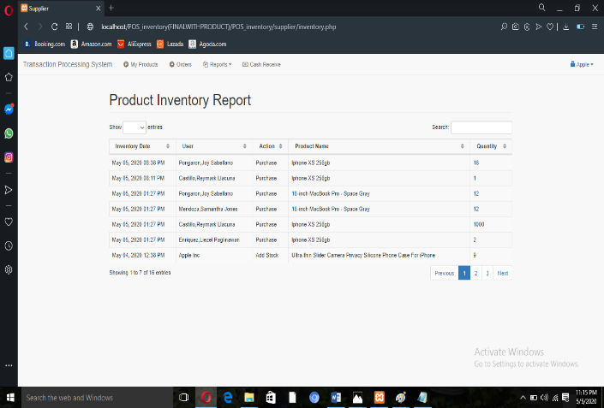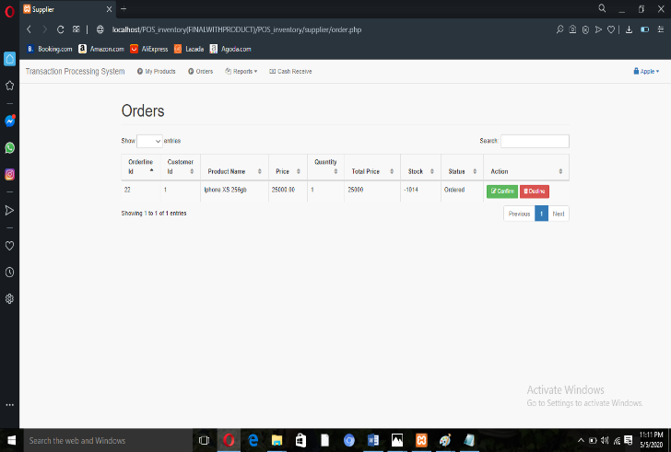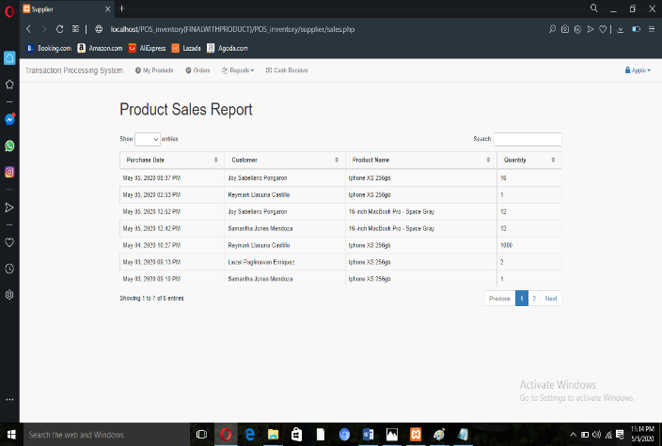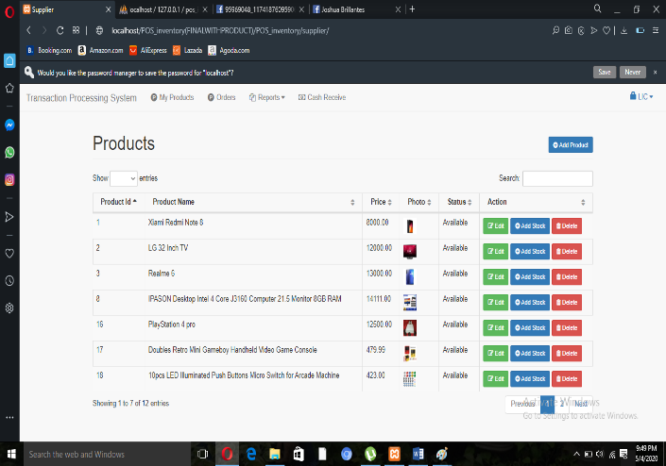

In the employee’s page. The employee will confirm the request from the supplier to deliver the customer’s order. The report in this page, either the product was received to the customer or not

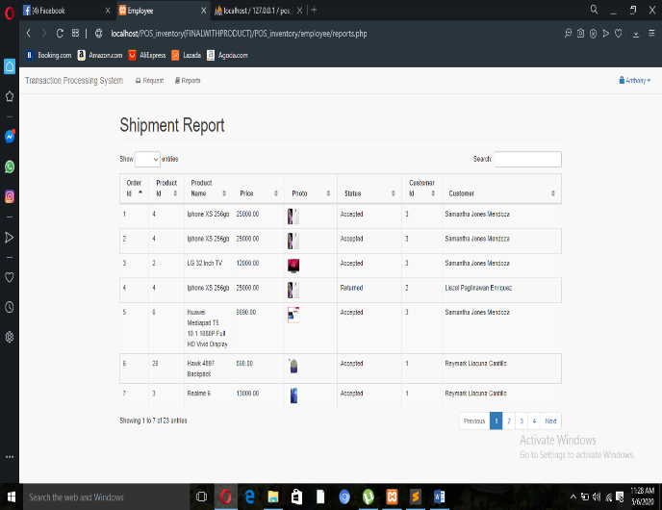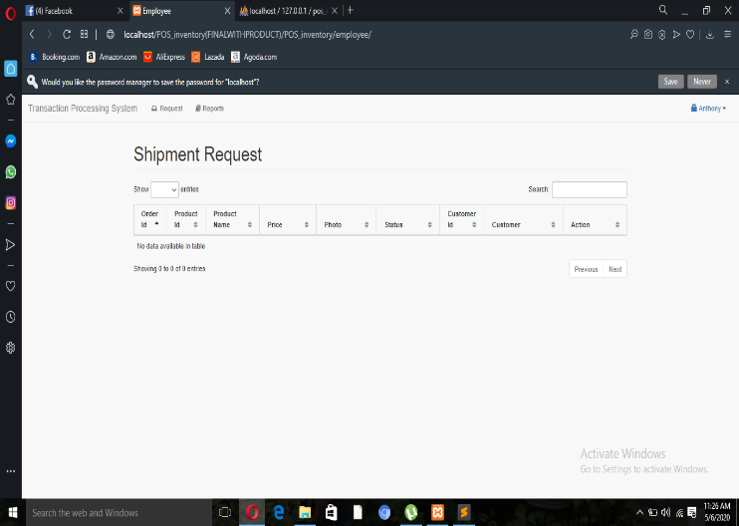

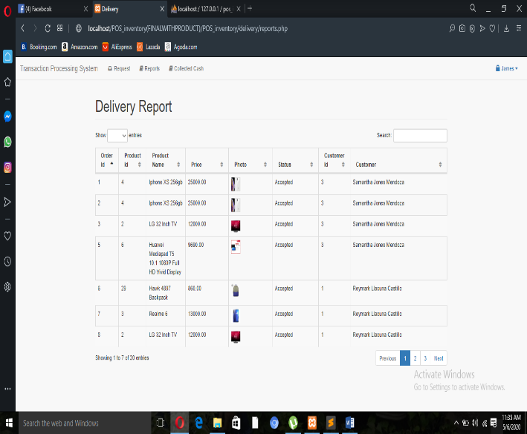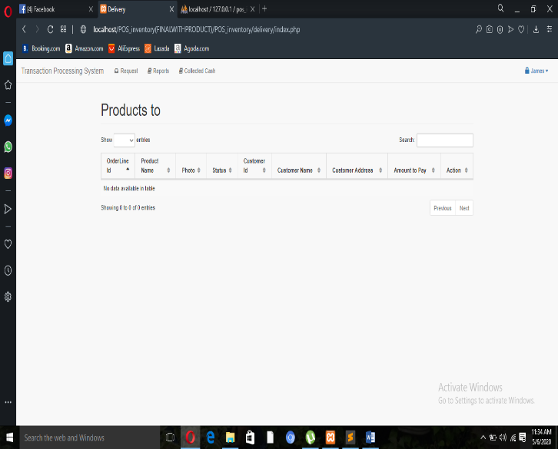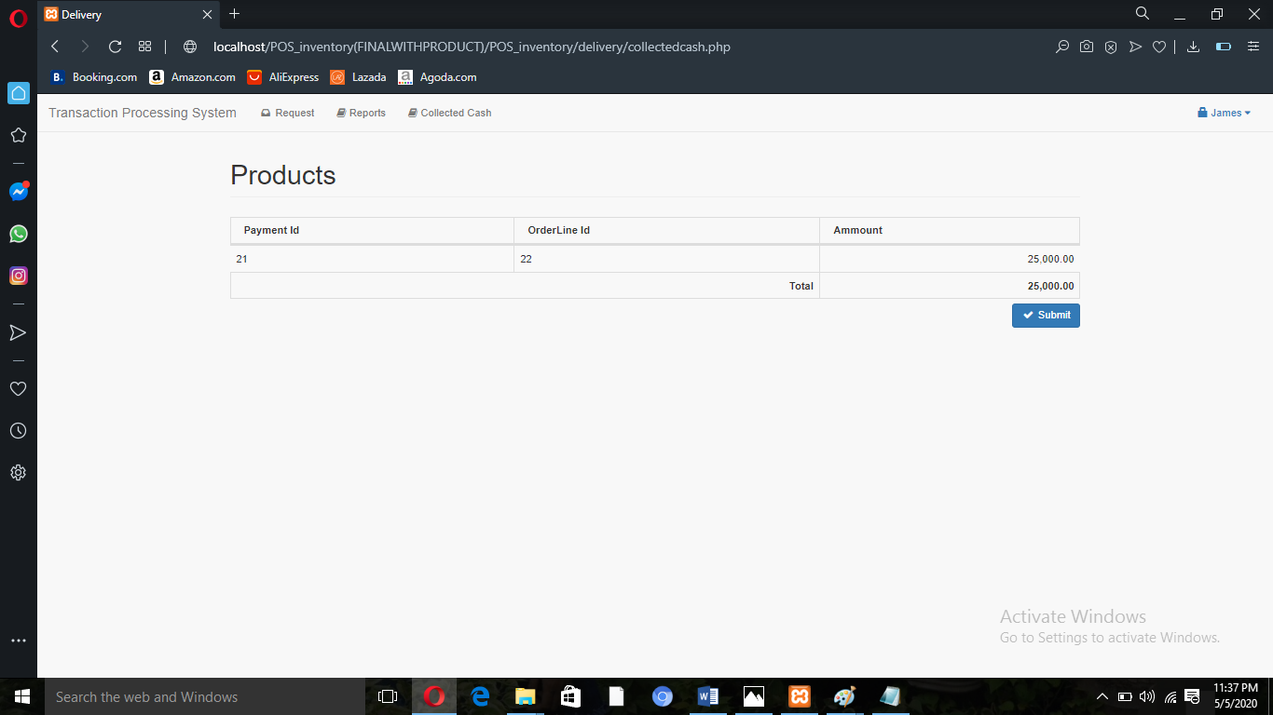In delivery page. We can see the report about the delivery transaction. It also have the reports if the customer receive the product or not. And in the collected cash, we can see the cash reports, the price of the product and it will be submitted to the warehouse.

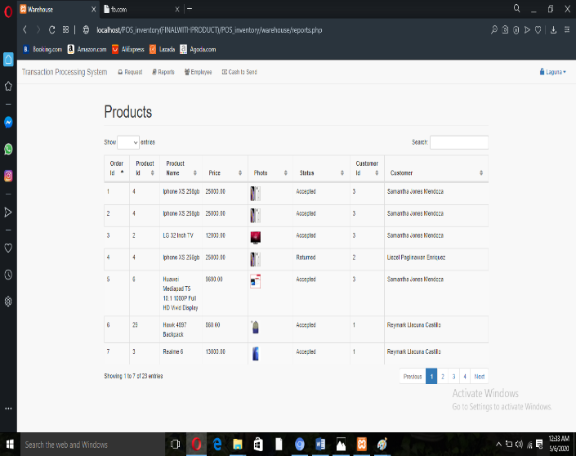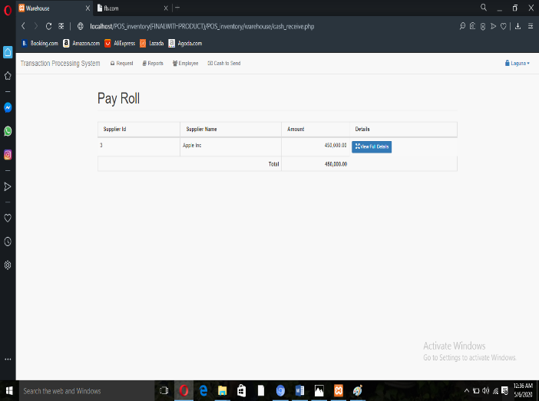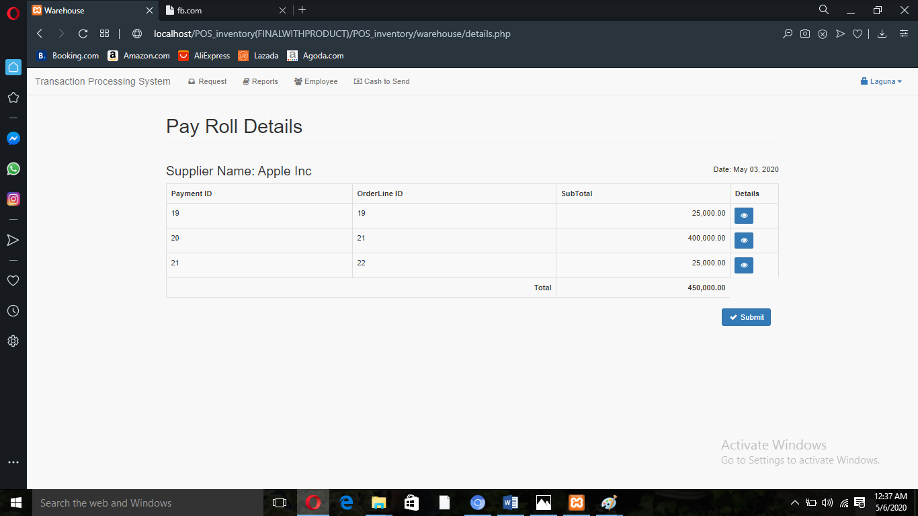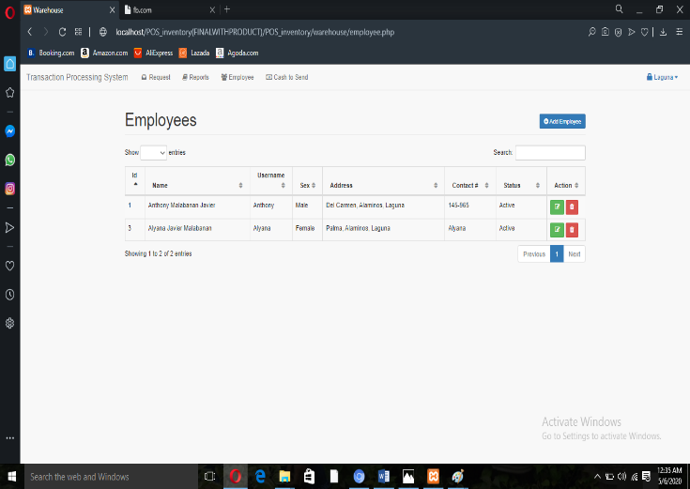In Warehouse page. It has a record for shipped request, it will confirm the items that can be deliver. It have also the report if the item was already delivered or not. The page also have the record of the status of the employees. In this page, we can edit or delete the details of the employees. In cash to send, it's about the cash that will give to the supplier. It also have the details of the products, the quantity, the price of the product and the total price after delivery.

